Posting instructions:
Start a post on your desired social platform – choose an image (only one per post), then type in the respective ‘Caption’ text to accompany the image. Recommendation: If possible, post early in the week (Mon-Wed) and early in the day (9am-12pm).
Week 1 | Topic | Social image/video | Post copy
 | Balance | 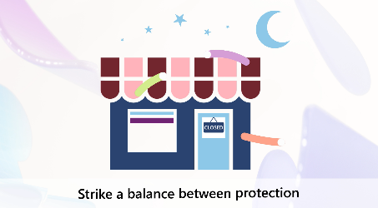  Placeholder image – Customize and Post the video “Balance” | Caption  The wrong security strategy can increase your risk. Strike a balance between protection and productivity with Microsoft 365 Business Premium. #SecureWithIntune
Week 2 | Topic | Social image | Post copy
 | Single solution | 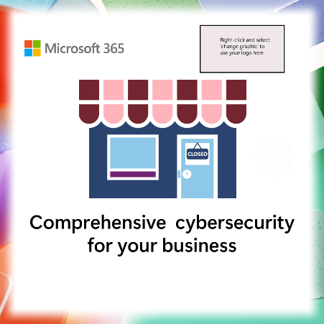 | Caption  Help secure your business with protection for devices, users, and files with Microsoft Intune and Microsoft 365 Business Premium. #SecureWithIntune
Week 3 | Topic | Social image | Post copy
 | Manage devices | 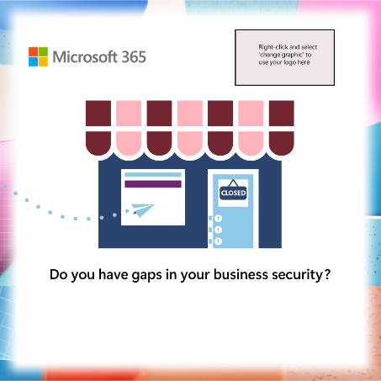 | Caption  Reduce risk with simple, unified security controls for iOS, Android, Mac, Linux, and Windows devices with Microsoft 365 Business Premium. #SecureWithIntune
Week 4 | Topic | Social image | Post copy
 | Ensure access | 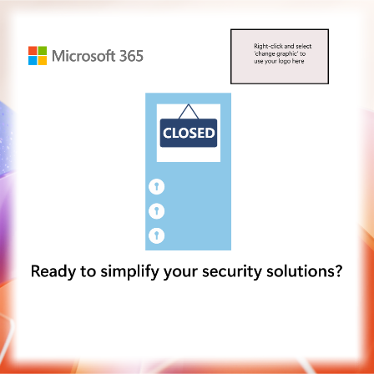 | Caption  Help employees securely access business apps where they work, using the device they prefer with Microsoft Intune and Microsoft 365 Business Premium. #SecureWithIntune
Week 5 | Topic | Social Video | Post copy
 | Risks | 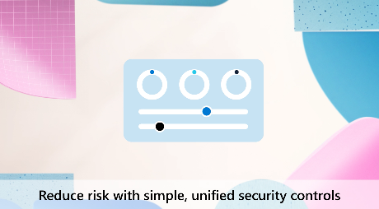  Placeholder image – Customize and Post the video “Risks” | Caption  Microsoft Intune gives you simple, unified controls to help reduce security risks for iOS, Android, Mac, Linux, and Windows devices. And it is included with Microsoft 365 Business Premium #SecureWithIntune
Week 6 | Topic | Social Image | Post copy
 | Manage devices | 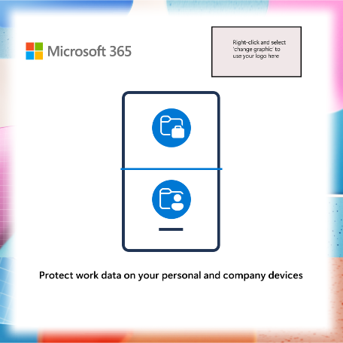 | Caption  Microsoft Intune helps you apply rules to help protect work data on company-owned and employee devices, keep company data from being shared, and remove business data from lost or stolen devices. And it is included with Microsoft 365 Business Premium #SecureWithIntune
Week 7 | Topic | Social Image | Post copy
 | Ensure access | 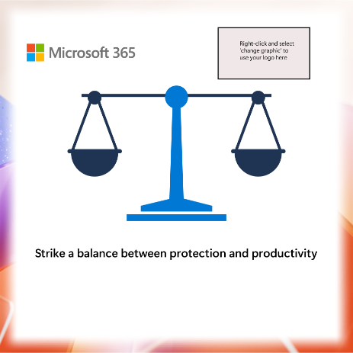 | Caption  Help keep your business protected and productive with Microsoft Intune and the collaboration and security tools included in Microsoft 365 Business Premium. #SecureWithIntune
Week 8 | Topic | Social Image | Post copy
 | Defend against cyberthreats |  | Caption  Help ensure that your business remains secure and resilient against attacks with the cybersecurity features included in Microsoft Intune and Microsoft 365 Business Premium. #SecureWithIntune
Week 9 | Topic | Social Video | Post copy
 | Tools |   Placeholder image – Customize and Post the video “Tools” | Caption  Cyber criminals take advantage of weak passwords and delayed updates. Help keep your phones and laptops more secure with Microsoft Intune, included with Microsoft 365 Business Premium. #SecureWithIntune
Week 10 | Topic | Social image | Post copy
 | Single solution | 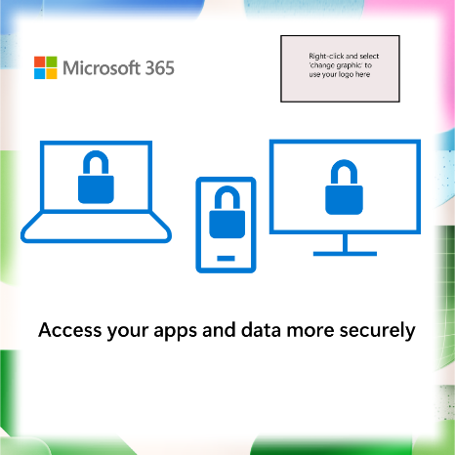 | Caption  Microsoft Intune is designed to work together with the tools in Microsoft 365 Business Premium to simplify security for your users, devices, and data #SecureWithIntune
Week 11 | Topic | Social image | Post copy
 | Manage devices | 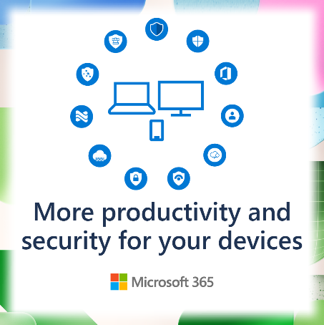 | Caption  Reduce risk with simple, unified security controls for iOS, Android, Mac, Linux, and Windows devices with Microsoft 365 Business Premium. #SecureWithIntune

